AI Lab Report
Lab Title: Minimax Algorithm and Alpha-Beta Pruning
1. Objective:
The objectives of this lab are:
- To trace the supplied game tree manually using the Minimax algorithm.
- To implement Minimax and Alpha-Beta Pruning in Python.
- To add a leaf-evaluation counter to both algorithms.
- To reorder branches and observe the effect on leaf evaluations.
- To verify that both algorithms return the same root value for the same complete tree.
2. Introduction:
Minimax and Alpha-Beta Pruning are search algorithms used in Artificial Intelligence for decision-making problems, especially two-player games.
Minimax selects the best possible move by assuming that both players make optimal decisions. One player is called MAX, who tries to maximize the score, while the other is called MIN, who tries to minimize the score.
Alpha-Beta Pruning improves the Minimax algorithm by avoiding the evaluation of branches that cannot affect the final decision. It uses two values, alpha and beta, to identify branches that can be safely skipped.
3. Minimax Algorithm:
Minimax works by evaluating the leaf nodes of a game tree and propagating their values toward the root.
- MAX node: Selects the maximum value.
- MIN node: Selects the minimum value.
- Leaf node: Contains a final score.
- Root value: Represents the best value available to the MAX player when both players play optimally.
The Minimax algorithm evaluates all leaf nodes in the given tree.
4. Alpha-Beta Pruning:
Alpha-Beta Pruning is an optimization of Minimax. It gives the same root value as Minimax but can evaluate fewer leaf nodes.
- Alpha: The best value MAX can guarantee so far.
- Beta: The best value MIN can guarantee so far.
- Pruning condition: When alpha is greater than or equal to beta, the remaining branches of that node can be skipped.
The effectiveness of Alpha-Beta Pruning depends on the order in which branches are explored.

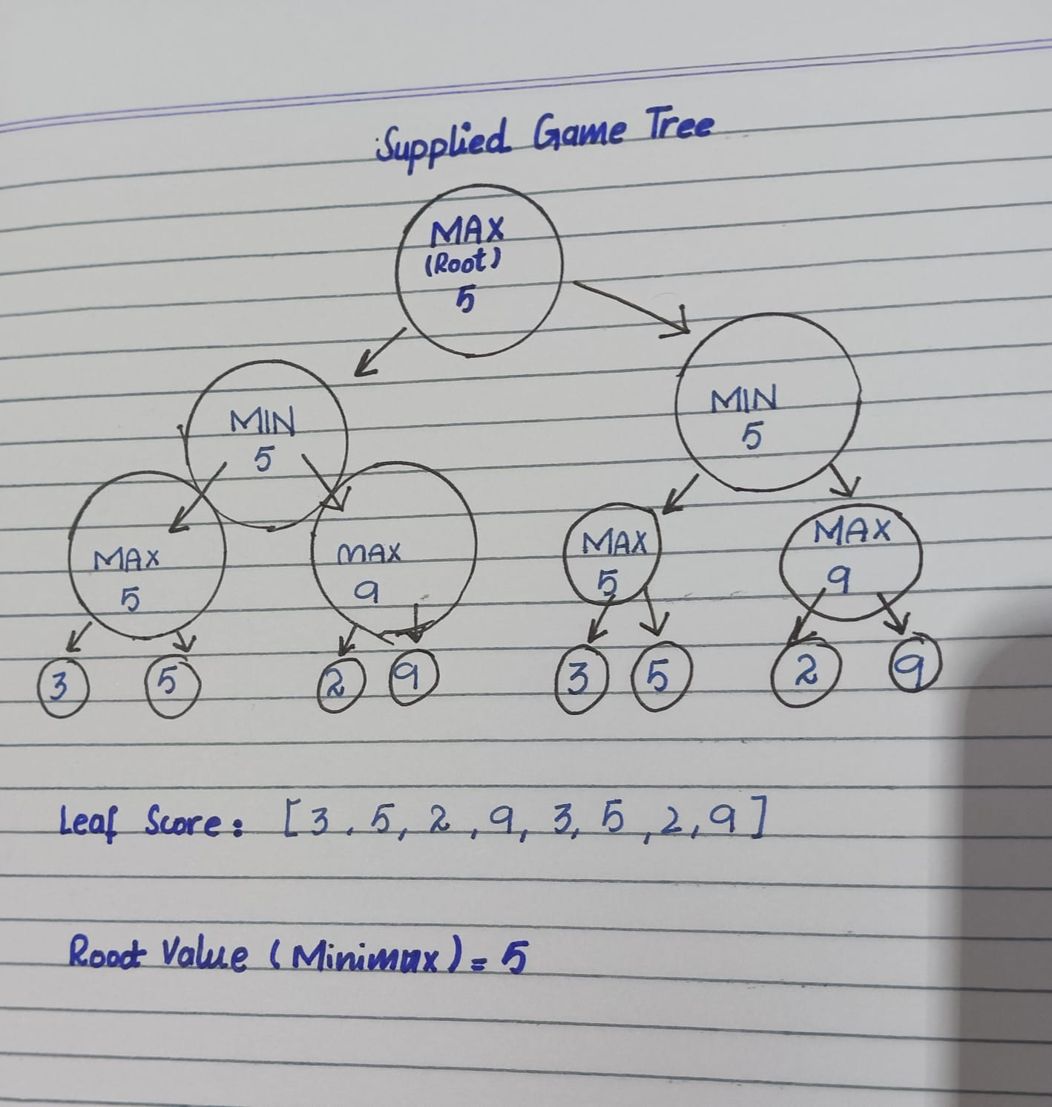
5. Given Leaf Scores and Tree Structure:
The leaf scores used in this implementation are:
[3, 5, 2, 9, 3, 5, 2, 9]
The tree is a balanced binary tree. The root is a MAX node, its children are MIN nodes, and the next level contains MAX nodes whose children are the leaf scores.
At the lowest decision level:
- MAX(3, 5) = 5
- MAX(2, 9) = 9
- MAX(3, 5) = 5
- MAX(2, 9) = 9
At the MIN level:
- MIN(5, 9) = 5
- MIN(5, 9) = 5
At the root:
- MAX(5, 5) = 5
Therefore, the Minimax root value is 5.
6. Manual Minimax Trace:
The tree is evaluated from the leaf nodes upward.
Node | Operation | Value
Left lower MAX | MAX(3, 5) | 5
Right lower MAX | MAX(2, 9) | 9
Left MIN | MIN(5, 9) | 5
Third lower MAX | MAX(3, 5) | 5
Fourth lower MAX | MAX(2, 9) | 9
Right MIN | MIN(5, 9) | 5
Root MAX | MAX(5, 5) | 5
The final root value is 5.
7. Implementation:
The program is written in Python and contains two algorithms:
- minimax() evaluates the game tree and counts each leaf visited.
- alpha_beta() evaluates the tree using alpha and beta values and counts only the leaves actually visited.
The program uses a counter list to track the number of leaf evaluations. Each time an algorithm reaches a leaf, the counter increases by one.
A helper function creates the binary tree from the supplied scores. Another helper function reverses the order of the branches for comparison.
8. Results and Comparison:
For the provided balanced binary tree and the original branch order, the expected results are:
Measurement | Minimax | Alpha-Beta
Root value | 5 | 5
Leaf evaluations | 8 | 7
After reversing the branch order at every internal node, the expected results for this particular implementation are:
Measurement | Minimax | Alpha-Beta
Root value | 5 | 5
Leaf evaluations | 8 | 7
Both algorithms return the same root value. Minimax evaluates all eight leaves, whereas Alpha-Beta Pruning skips one leaf in this experiment.
The leaf count is specific to this tree and branch ordering. Different tree structures or branch orders may produce different Alpha-Beta evaluation counts.
9. Limitations and Analysis:
Alpha-Beta Pruning does not guarantee that every tree will have fewer leaf evaluations under every ordering. Its performance depends on the structure of the tree and the order in which the children are visited.
In the worst case, Alpha-Beta Pruning may evaluate as many leaves as Minimax. However, with a favorable branch order, it can prune more branches and reduce computation.
The program uses a balanced binary tree constructed from the given scores. If the supplied lab-manual tree has a different structure, the program and manual trace must be adjusted to match it.
10. Conclusion:
In this lab, Minimax and Alpha-Beta Pruning were implemented in Python. The leaf-evaluation counters were used to compare their performance, and the branch order was changed to observe its effect.
Both algorithms returned the same root value of 5 for the tested tree. Minimax evaluated all eight leaves, while Alpha-Beta Pruning evaluated seven leaves in the tested ordering. This demonstrates that Alpha-Beta Pruning can reduce unnecessary evaluations without changing the Minimax result.
11. References:
- Artificial Intelligence Lab Manual, CAI601400, relevant Minimax and Alpha-Beta Pruning section.
- Course lecture notes on adversarial search and game trees.

